Invoice Management

# Creating an Invoice

1. Login to the website.
2. Press the button on the home page labeled Create Invoice.

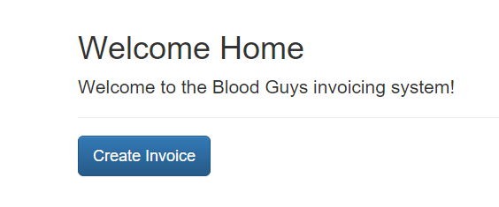

1. After pressing the Create Invoice button you will be taken to the first section of the invoice. Complete the fields and press the Continue button to save your entries and proceed to the next section.
2. To move to a previous section, complete the fields and press the Previous button. This will save your entries and proceed to the previous section.

# Editing an Invoice

1. Click the Invoices header from the menu. This will show a table of all invoices that have been created by the currently logged in user. Note: Users that are admins will see all invoices.



1. Click the Edit Button 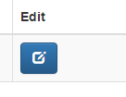for the invoice to be edited. This will bring up a section selection screen.
2. Select the section you would like to Edit or Complete by clicking the button next to that section.

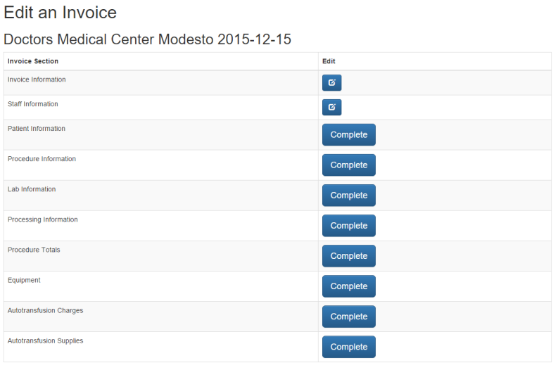

1. Complete the fields and press Continue to move to the next section. If editing a section you may Press the Update button to update that section and return to the Invoices List screen.

# Deleting an Invoice

1. Click the Invoices header from the menu. This will show a table of all invoices that have been created by the currently logged in user. Note: Users that are admins will see all invoices.



1. Click the Delete Button (Red Trash Can) next to the invoice you would like to delete.

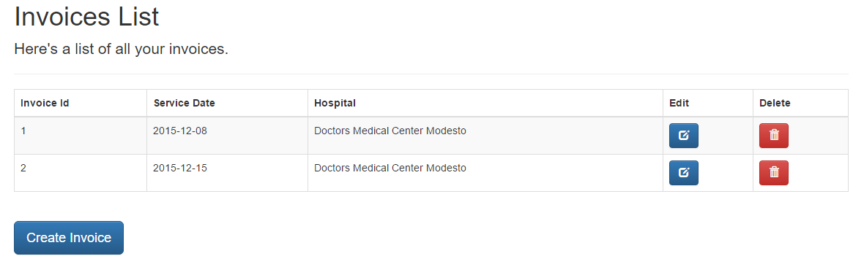

1. The invoice entry will disappear and a success message will show stating that the invoice was successfully deleted.